**Commission Record**

This document summarizes the setup of the commission report of sales rep Partners. It works using a scheduled script, where it lists a sales rep partner’s Tracfone, sim sale, activation bonus, airtime bonus, warehouse, and miscellaneous commissions and their total commission respectively. It shows the current user’s commission report on their homepage when they log in.

The navigation for this section is **List > Custom > Commission Record**.

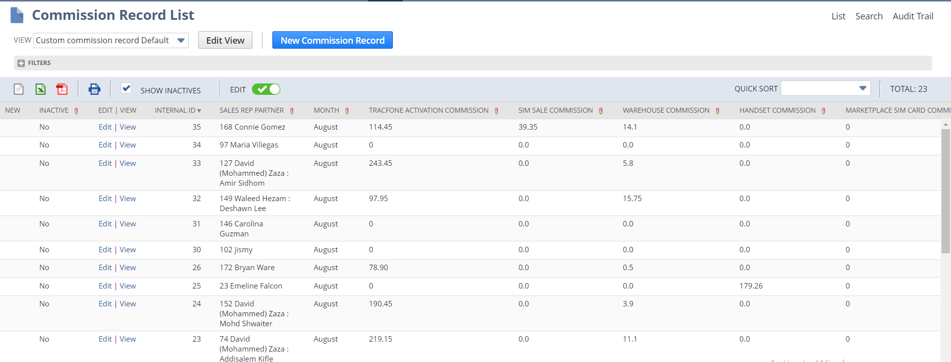

This will list the commission of Each Sales Rep Partner for the last month. The schedule script will update the commissions on each month.

There are several kinds of Commissions are available for a sales rep partner, such as Tracfone Activation, Sim sale, Warehouse, Marketplace Sim sale card, Handset, Air time bonus, Activation bonus and Miscellaneous Commissions. Each section has different formula for calculating the commission. Each of these are different custom records and it stores the commission details.

**Sales Rep Partner**

For a sales rep partner record, they have a **Class** and **MM Commission Profile** values. The commission is calculated based on these values. There are 5 kinds of classes are available now;

* New York
* North Carolina
* Virginia
* Illinois
* Texas

Likewise, there are 3 kinds of MM Commission Profile Values are available.

* + Regular Marketing Manager
  + Regional Manager
  + National Manager

These values are like a division of a structure. Ie; Each of these is coming under another. **Regular Marketing Manager** is the lowest position. **Regional Manager** is the second highest level and the **National Manager** is the Highest position of these Sales rep Partners.

Each Regular Marketing manager should have a sale of a minimum quantity of products to get the commission. If they have sold a lesser number of products than the threshold quantity, they won’t have any commission. The Commission Amount will be changed according to the quantity sold. This minimum amount will be changed according to the Commission Profile of the sales rep partner. Ie; a Regional Marketing manager should have a minimum quantity than a Regular Marketing manager should have. In the case of National Managers, the minimum quantity will be higher than the others.

As previously said, there are different kinds of commissions are available. Each section has a different commission rate. These rates can be viewed on the Sales rep partner’s **Vidpay/ Netsuite Commission Rates** subtab.

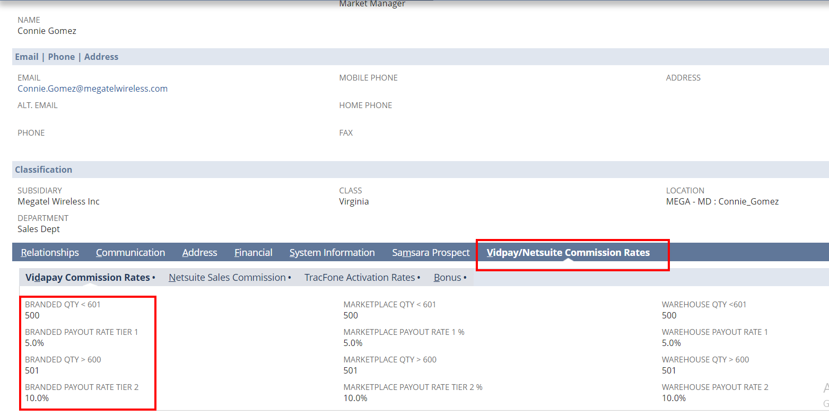

Each section will have different threshold quantity and different commission rate.

**Tracfone Activations**

Tracfone has several Activation tiers on its record. The commission rate is based on the activation tier. Total commission of a sales rep partner for TracFone is calculated by

**Total number of products sold * Tier commission rate**

Different activation tiers available are

* AR
* ELITE
* EXCLUSIVE
* MEMBER
* PRO

Tracfone activation commission rate can be viewed on the **Vidpay/ Netsuite Commission Rates** subtab of the Sales rep partner

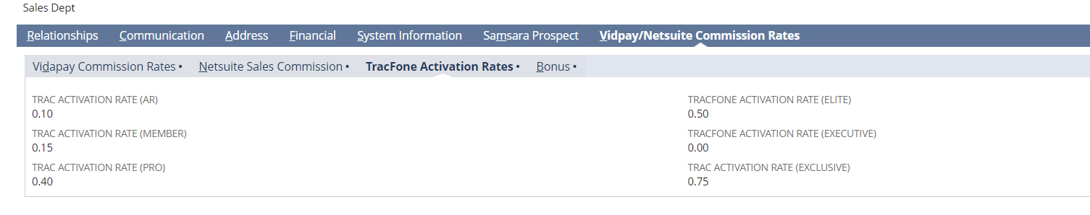

**Sim Sale Commission**

This section will calculate the commission of Sim card sales of a sales rep partner. This commission is calculated by

**Total number of Items sold * Commission Rate**

Commission rates of this section is on the **Netsuite Sales Commission** section of **Vidpay/ Netsuite Commission Rates** subtab of the Sales rep partner.

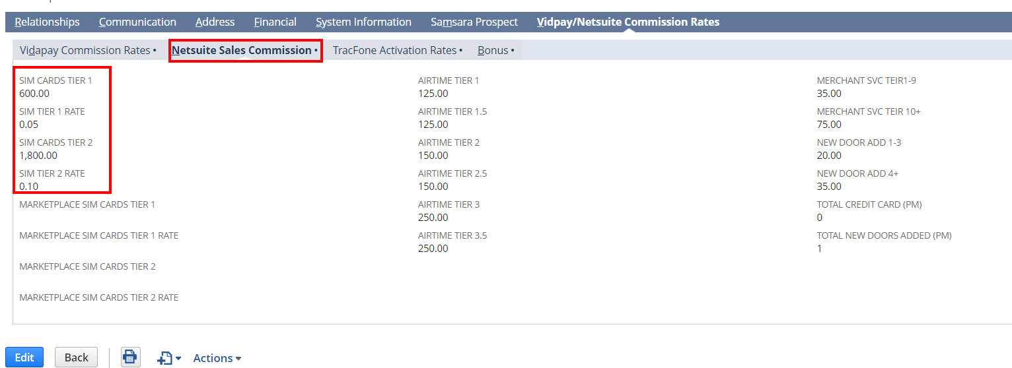

On the following example, we could say that, if the sales rep partner has sold minimum of 600 items or below 1800, then the commission rate will be 0.05. ie; total sold items are between 600-1800, the commission rate will be 0.05. If it is higher than 1800, then it will be 0.10. If the total quantity is lesser than 600, there won’t be any commission.

**Warehouse Commission**

It uses combines 4 searches on the script to find the warehouse commission.

1. Branded Handset search

2. Marketplace Sales search

3. Transaction Search and

4. QPay Market place search

It will find the total quantity of items sold on each search and the sum of all of these will be the warehouse commission of a sales rep partner.

**Handset Commission**

This commission is calculated by

**Total number of Products sold * Commission rate**

The commission rate is available on

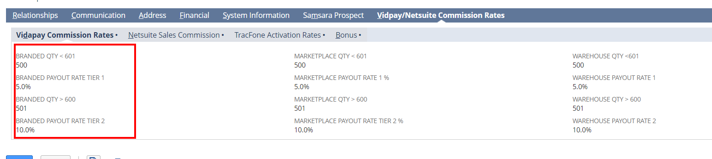

**Marketplace Sim Card Commission**

This commission is calculated by

**Total number of Products sold * Commission rate**

The commission rate is available on the Marketplace Sim card tier and Rate fields on the **NetSuite Sales Commission** section.

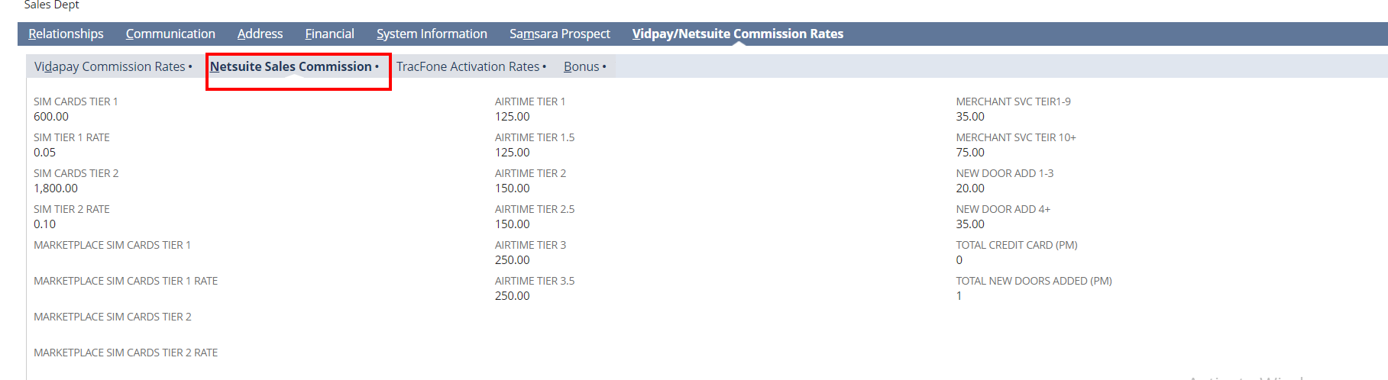

**Airtime Bonus** & **Activation Bonus**

The commission rate is available on the **Bonus** section.

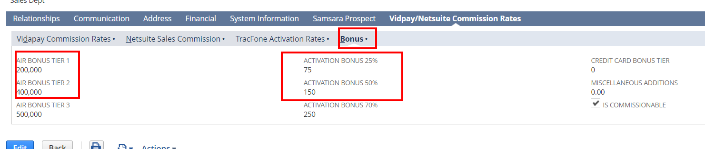

Rate is calculated according to the tiers.

**Miscellaneous Additions**

This is the sum of Airtime Bonus and the Activation Bonus of a sales rep partner.

**Related Scripts**

* [JJ SS MTW 329 Commision Report](https://3815745.app.netsuite.com/app/common/scripting/script.nl?id=553)

**Note:** The above script is a scheduled script. Currently it is not scheduled. This script needs to be executed manually on every month. It is usually done by the client. If the client needs any help, we need to execute it.

**Record Setup**

The custom record is actually created for each Sales rep partner and currently, we haven’t done anything for restricting duplicate record creation. Ie; now, we could create more than one record for a sales rep partner. So, don’t create multiple records for a sales rep partner.

**Portlet Setup**

There is a portlet setup is created on the Dashboard to show the commission report of the logged sales rep partner. We’ve used a portlet script and a saved search for this setup.

Following are the steps to setup a portlet

1. Click on the Personalize link in the Home Page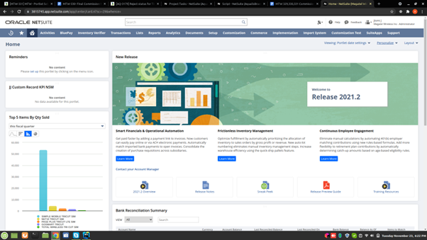
2. Click ‘Custom Search’ option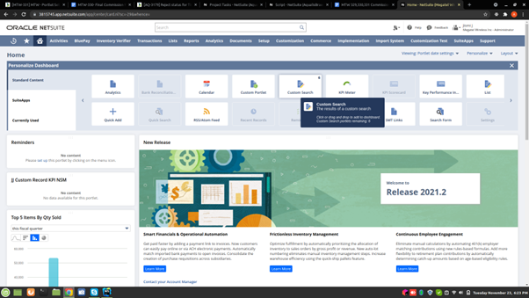
3. Then a new Portlet Page will Populate under the options. Click ‘Set Up’ link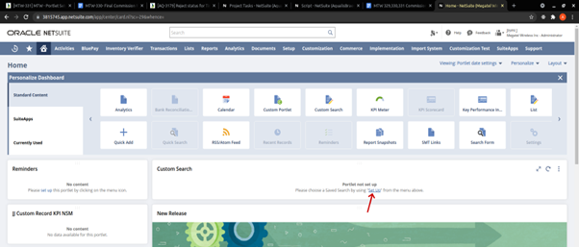
4. A Popup window will open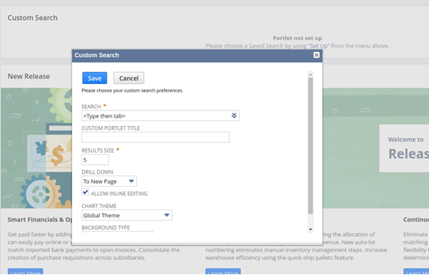
5. From that select the search ‘Commission record Search’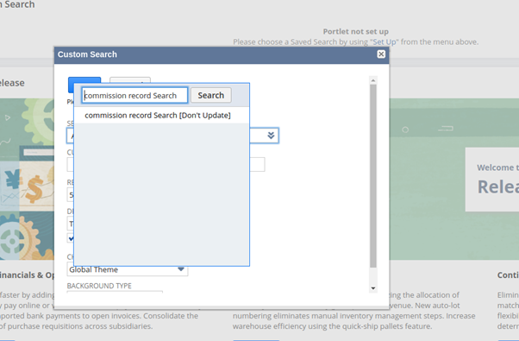
6. Then give a Suitable Title for the Portlet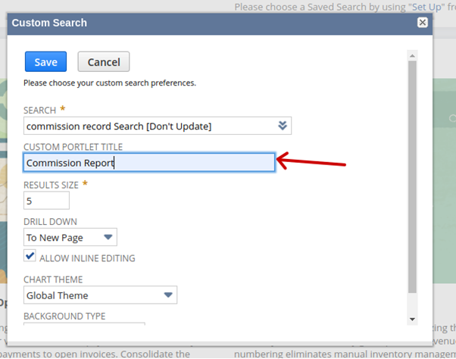
7. Portlet will be Shown in the Homepage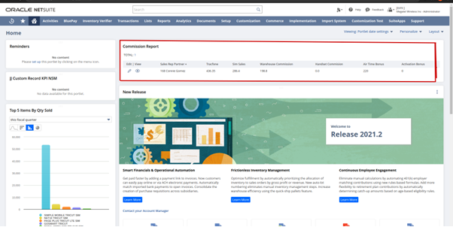

**Related Script:** [JJ PL Commission Report MTW-337.js](https://3815745.app.netsuite.com/app/common/media/mediaitem.nl?id=1745111&whence=)

**Related Saved Search:** [commission record Search [Don't Update]](https://3815745.app.netsuite.com/app/common/search/searchresults.nl?searchid=1227&whence=)

**Commission Report**

This section lists the commission report of the sales rep partners. By default, it lists the commission details of the previous month of every sales rep partner. There are 2 filters available on this. Users could list it according to any particular sales rep partner or they could list the commission report of a particular date range. It was already existing work and an update that the client has mentioned is adding a new section Marketplace SIM card commission.

**Import System**

This section is used for importing the product details that are sold by sales rep partners. This section includes several sections to import the products. Navigation for this section is **Import system > Import system > Import system**. In this section also an addition that the client has mentioned is to import marketplace sim products.